Project Design Phase - I ( Solution Fit )

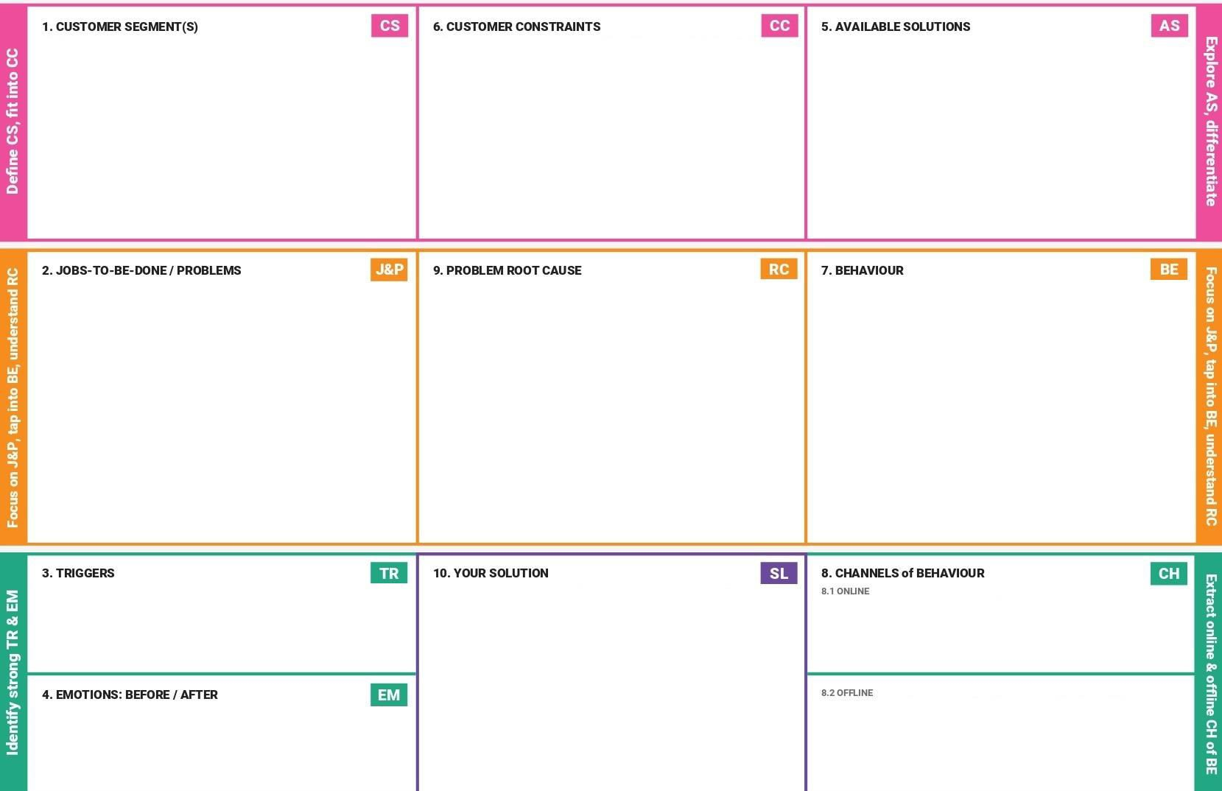

**Project Title :** Signs with smart connectivity for better road safety **Team ID :PNT2022TMID24784**

* Transportation users
* Engineers who maintain and oversee road safety
* Government transportation.
* The vehicle should have digitally supported sensors that can be compatible with the smart sign boards.
* The general public who own or use automobiles(of any type).
* There are now useless analog road safety signs in use.
* Signs painted on walls and roads by the corporation which disappeared or perished in a period of time
* Static boards are unreliable for determining the weather at a location.
* Since the general population uses a variety of routes for transportation, forecasts for the desired routes based on local weather should be available.
* Choosing the location of the smart sign board
* Maintaining data correctness;
* The potential for the smart sign boards sensors to malfunction
* The possibility of external or internal forces damaging the sign boards.
* The placement of static notice boards is incorrect and not apparent.
* The static boards cannot be used to predict the weather at the specified location.
* People are conscious of the traffic conditions around them and desire to make their travels easier and more comfortable.
* Online influencers can promote the smart sign boards using their respective influencing channels.
* Because the public is unaware of static sign boards, more attractive smart sign boards have been produced.e
* Traffic law maker should give awareness programs to the public
* Connect the smart sign boards so you may use their applications, such as speed limits and weather forecasts.